**Technical paper addressing the Design and Development of a DSLR Camera Slider.**

**Team**: Zien Zheng, Patrick O’ Connor, Aaron Molihan.

BEng (Honours) in Mechanical Engineering – Energy.

AIT, Dublin Road,

Athlone, Co. Westmeath.

[A00268964@student.ait.ie](mailto:A00268964@student.ait.ie), [A00245151@student.ait.ie](mailto:A00245151@student.ait.ie), [A00251148@student.ait.ie](mailto:A00251148@student.ait.ie)

**Abstract**

This paper focuses on the design of a camera slider capable of smoothly moving a DSLR camera and attached lens in a linear path using CREO Parametric 7.0. It is required that the slider mechanism can facilitate both automatic and manual motion while also reducing oscillations due to vibrations by carrying out a motion study. This will also help design against resonance. The Ashby method of material selection along with the CES software process are discussed. An in-depth analysis of the material selection process is presented, which implemented a camera slider design that was sturdy enough to support a 2kg DSLR camera, portable due to its light weight and design while also incorporating a factor of safety which will allow for misuse, unexpected loads or degradation. A conclusion on all findings and recommendations for further work are deliberated.

**Nomenclature**

M= Bearing slot

N= Crank control arm

P= horizontal support

****= The angle between the camera slider and the support

L1= Distance between centre and bottom of support

L2= Distance for the centre of the horizontal support to the end

β= Angle of the vertical support and the slider

E= Young’s modulus

δ= Stress

P= Force in Newtons

L= Length

E= Young’s modulus

I= Moment of Inertia

FOS= Factor of safety

**Introduction**

Through the design phase arises the task of venturing into the material environment in order to choose the best material for a product of a particular application. However, before diving into the material world, there are many design aspects to understand, and a comprehensive approach is needed. However, material properties are just one factor to consider; cost, machinability, affordability, and recyclability can also be factors to consider when choosing the best candidate. A systematic approach to material selection was developed by Michael F. Ashby, a British metallurgical engineer known for his material science research. Material selection is divided into four phases by Ashby's design-driven approach: translation, screening, ranking, and seek documentation. After completing these four stages, you will be able to comfortably choose the best material for your build. The design process for the pan device must allow for free motion of the piece and the ability to secure the piece if required. As well as for consumer desire for light weight yet offering a reasonable rigidity of the piece as to prolong life.

**Problem Statement**

The camera slider is widely used in professional photography. Due to the complexity and cumbersomeness of existing camera slider, it is impracticable to film randomly on location. Meanwhile, the faultiness of it is that the shooting screen is not stable and smooth, which waste manpower greatly. With respect to its function, the most of it just has a manual or automatic mode, and the relative displacement and the inclination angle are limited. This project requires the development of a camera slider capable of smoothly moving a DSLR and attached lens in a linear path of at least 75 cm and maximum 1.2 m. Moving the camera in a manual mode and automatic mode must be included, movements should be stabilized so that oscillations are avoided (or minimized) and the option to pan the camera as it moves along the length of the path must also be included. The systems must be light weight and portable and can carry a Canon, Nikon or Sony DSLR with a manufacture specific camera lens or a third party manufactured lenses such as Tamron or Sigma.

Figure Ashby's Method

**The Michael F. Ashby Method**

The Ashby method of material selection is regarded as an effective design technique and is hailed as a popular approach by designers and engineers all over the world. The approach has been categorised as design-driven and systematic. All this begins with determining the material characteristics profile which you desire. The said profile is then evaluated to different materials to determine which one is most suitable to the profile. The four steps of Ashby's material selection process are shown in Figure 1. When it came to content selection, Ashby changed the game. Feature, Material, Geometry, and Processes are the four steps in his system. As well as this, Ashby consulted on the divisions in class and sub-classes. As a result, he has established a systematic approach that associates a performance index with the predicted mechanical functions of an object that must be optimized. Instead of using a single elastic module, these indices allow for better consideration of all the properties expected of a material, like specific stiffness (ratio between elastic modulus and density). This method allows for the reasonable choice of the appropriate materials for the desired application.

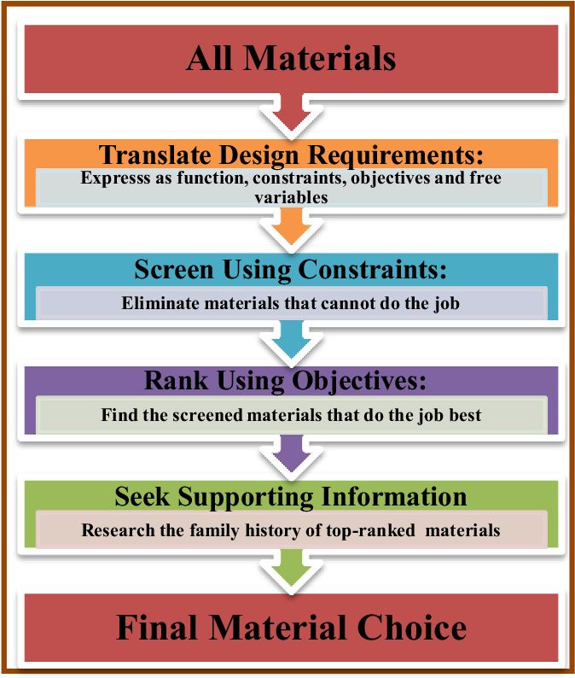

(Mehmood, 2018)

**Translation**

It is possible to specify the component's function, constraints, purpose, and free variables during the translation stage. Table 1 defines the procedures involved in each of these four phases. The function of the variable is determined by the constraints associated with it. If restrictions are violated, the part will stop working as it should.

Table 1 Procedures

|  |  |
| --- | --- |
| **Definition** | **Explanation** |
| Function | What does the component do? |
| Constraints | What non-negotiable conditions must be met? What negotiable but desirable conditions must be met? |
| Objectives | What is to be maximized or minimized? |
| Free Variables | What parameters of the problem is the design engineer permitted to change? |

**Screening**

Material candidates are divided into desirables and non-desirables at the screening period. The materials are subjected to design constraints at this stage. For example, if the specification calls for a part to be suspended in water, all materials with densities greater than 998 kg.m-3 are ruled out. Consequently, screening is a stage that is entirely based on the design's purpose and constraints.

**Ranking**

Generally, the ranking stage collects all the possible materials and attempts to highlight the best of them. The graded materials are the product of the screening stage and are subjected to mathematical interrogation using material indices. A material index quantifies a material's suitability for a specific application; it tests how a certain material can function. Modification of the material index, whether it is minimized or maximized, will result in the most suitable material. The content index must adhere to the goals set out during the translation period.

**Seek Documentation**

The seek documentation stage comes after the ranking stage, and it is here that the material's content is analysed. This stage provides information about the material's availability, machinability, and other characteristics. This step is critical in identifying any mistakes made in the previous steps. The seek documentation stage is a direct product of all the previous stages being fully completed, and it eventually determines the best material selection. By using the Ashby system and CES, a materials and processes software, the design process can commence.

**Design Critique**

To determine the minimum Youngs modulus of the required material to allow for a maximum deflection of 1mm, it is necessary to examine the methods of fixation. It was proposed in the initial stage of the design process to allow the camera slider to have two fixation methods. The first method is to have the camera slider supported at both ends with adjustable support brackets for levelling the device. This type of simply supported beam can be seen in figure 2 and the formula (equation 1) can be manipulated to determine the minimum Young’s modulus ‘E’ (equation 3).

Figure Simply supported beam

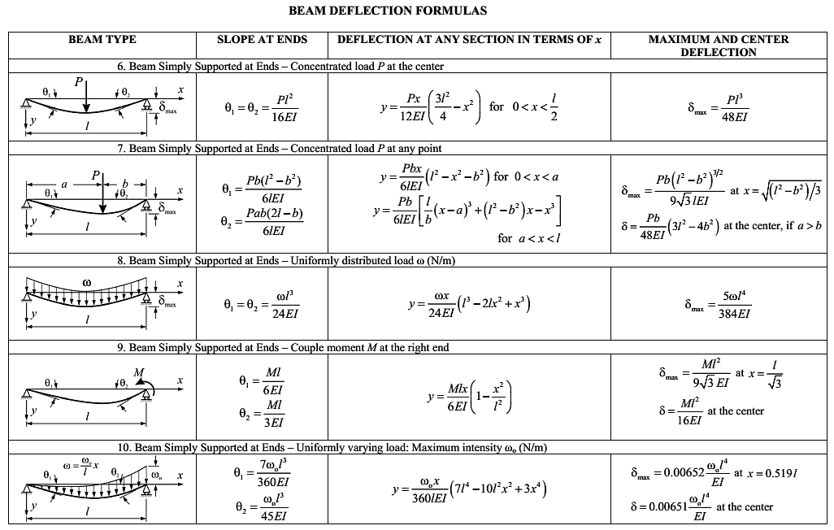

Equation 1

It is also vital to incorporate a factor of safety (FOS) into the design. This expresses how much stronger a system is than it needs to be for an intended load. This FOS will allow for misuse, unexpected loads or degradation. It is a ratio of maximum strength to intended load for the item that was designed and can be seen in equation 2. It would be necessary to physically test the stress properties of the item in a real-world project but for this design, a FOS of 2 will be used (Anon, 2010). This implies that the camera slider will exceed the maximum deflection limit of 1mm under twice the design load, 40N.

Equation 2

Equation 3

To determine the I value equation 4 is used. From this it is possible to calculate the Young’s modulus ‘E’.

Equation 4

The second method of fixation allows for the camera slider to be fixed at the midpoint, hence the 5 holes. These are for the attachment of a tripod stand which would assist in using the camera slider on uneven terrain. This method has the simply supported beam supported at the midpoint (figure 3) and the formula (equation 5) can again be manipulated to determine the minimum Young’s modulus ‘E’ for the required material. The ‘I’ value is the same as the first method as the geometry of the camera slider does not change.

Figure Supported at midpoint

Equation 5

As the Young’s modulus for the second method is greater, meaning the material must have a greater tensile stiffness than 27.69GPa to fulfil the maximum deflection requirement of 1x10-3 [m] this is the value which will be used in the limit stage of the CES Granta software seen in figure 4.

Figure CES Granta Selection Stage

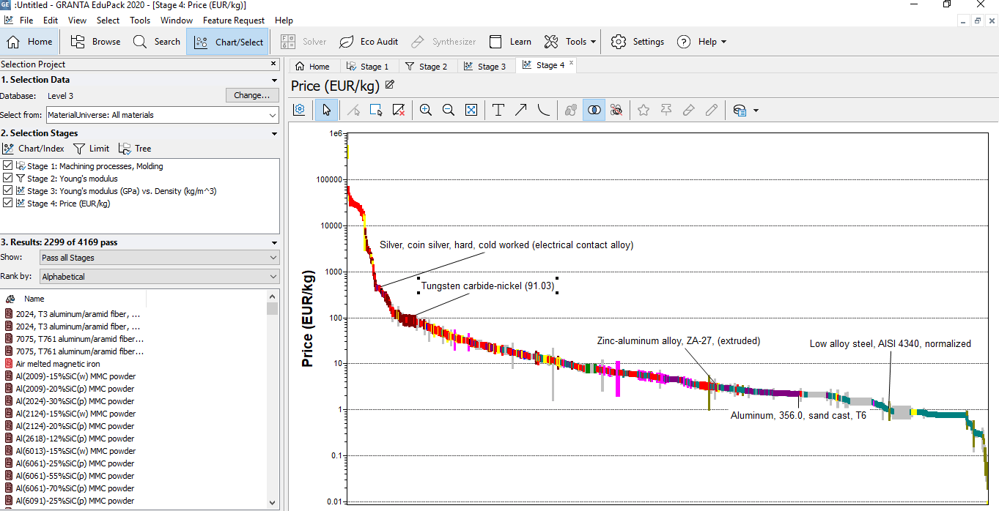

; Represents the material properties of the component. In order to maximise Young’s modulus, the equation is inverted and becomes; and can be expressed in logarithmic form in order to determine a slope; Log (E) = 2 Log (p) + 2 Log (C), where 2 is the slope of the line.

This value will be used to construct a slope on the graph illustrated in Figure 5 and the preferred materials will be identified.

Figure Young's modulus with slope

When examining the suitable materials from the performance index it is noticed that there is a huge price range from as much as €100/kg to €0.50/kg. As price is one of the constraints of the selection it must be taking into consideration (Figure 6).

Figure CES Price Constraints



After investigating all suitable materials from the performance index, it was determined that two materials would be ideal candidates for this specific design, Low Carbon Steel and Aluminium alloys. They both satisfy the limiting factors and on inspecting the processability (Figure 7), they both match the criteria.

Figure Processability of some metals

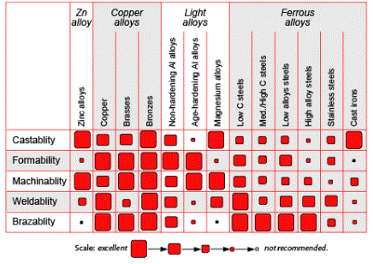

On further evaluation of the 2 materials, it is noticed that there is a big difference in the weight of both materials, with Low Carbon Steel being twice as dense as Aluminium alloys. As it is laid out in the problem statement that the camera slider needs to be light weight, it was decided that Aluminium alloys would be the material of choice. Although Low Carbon Steel costs €3 less per kg the benefits of the lightweight Aluminium outweigh the cost.

**Model**

**1.Final Assembly**

The camera slider has a moving range of 1.2[m]. A stepper motor was used for controlling the direction and speed of the motion. The camera platform was tied by a transmission belt at two ends of chassis of the platform. Then, at two ends of the slider, the belt was attached to two rollers where one roller was fixed on the transmission shaft of the stepper motor, and another roller act as the driven roller fixed at the opposite side of the slider.

 The final assembly of the camera slider is shown below in Figure 8.

Figure Camera Slider

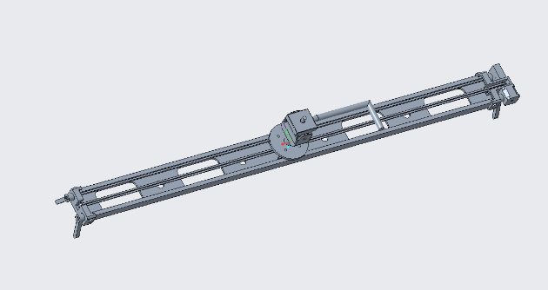 It has conducted in design critique that for the tripod mode of fixation, it requires stronger structure comparing to the simply support fixation mode.

**2. Slider**

The slider design is essential in this project because it will influence the total weight of the slider (Figure 9). Consequently, it should be as light as possible for carrying around, but the strength should be strong enough so the effect from the deflection of the beam can be neglected. So that the picture captured by the camera will not be ghosting and tearing when the camera is moving.

Figure Slider model

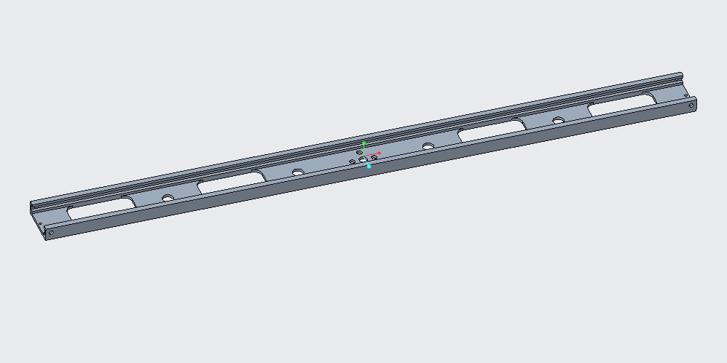

In design process, the concept of the slider is to be lightweight, so, there are 4 rectangle holes milled to reduce the total weight of the slider. As most of the forces are applied to the slider vertically, by milling these holes is the best way to lose the weight, and for the whole structure the strength loss will be minimal.

The fixation method for the slider will influence the functionality of the camera slider. In this model, there are two methods for fixation that suit for utilisation in different scenarios.

1. For the first method, at the centre of the slider, there are 5 holes that are drilled which allows the slider to fit in a tripod stand. For this fixation method, based on the design critique result, it requires stronger of the structure.

Figure Tripod fixation point

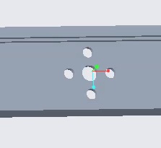

1. For the second method, using 2 covers fixing to both ends of the slider, for each of the covers, two rotatable support brackets are mounted which is shown in Figure 11

Figure Support Brackets

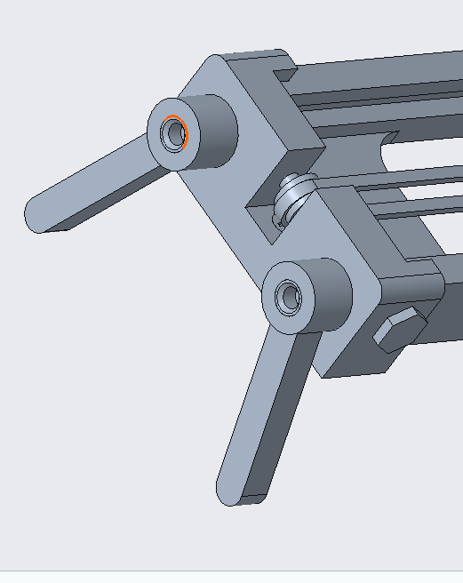

In simulate, consider the FOS of 2 which the force applied is 40N, by using the static study of using the tripod stand fixation, the study result is shown in figure 12:

Figure Static study result

The maximum deflection is 1.67mm, which has exceeded the expected limit of 1mm. As in design critique, it is using a rectangle beam for the estimation, which gives a range for choosing the material. Hence, the sensitivity study was carried out for more further dimension design based on this structure.

In first sensitivity study, by changing the thickness of extruded part from 15 to 24mm which will lead to the thickness of plate shown in figure 13 changes from 1 to 10mm,

Figure Sensitivity study variable

The maximum deflection for different thickness is shown in figure 14:

Figure Sensitivity study result

From the sensitivity study result, it tells that the deflection was minimized when the thickness of extruded part is 15mm which is 10mm of thickness of the plate, it has the minimum deflection of 1.2475mm.

Then, for the second sensitivity study, the height of the slider was added as one of the. Figure 15 has shown the second sensitivity result:

Figure Sensitivity study of height and thickness

From the graph, it tells that after 6 steps, the maximum deflection of the slider is 0.963mm which is smaller than 1mm.

In the second sensitivity study, the thickness of the plate was changed to 20mm and the height of the slider is optimised to 28.5mm, which gives the maximum deflection of 0.963mm of 2.3kg that meet the requirement.

**3. Roller**

To avoid the slip of the belt, roller with gear was designed as shown below:

Figure Roller at chassis of the platform (Left) and two ends of the slider (Right)

**4. Platform**

The platform is combining of a chassis with four scroll wheels and a round cover for attaching the station. As shown in Figure 17.

Figure Platform

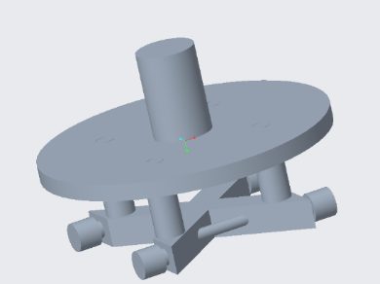

These four scroll wheels will fit into the slide to achieve the smooth motion of the camera.

**5. Manual Mode**

At the right bracket where the stepper motor is positioned, a knob is incorporated as it can move the slider manually, which is shown in Figure 18.

Figure Manual movement next to right bracket

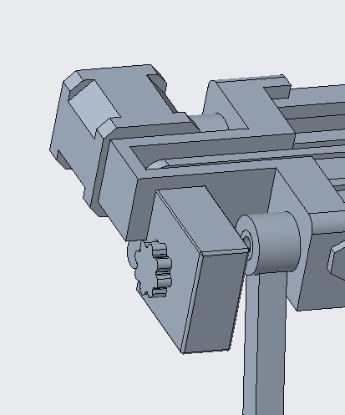

Within the box, it is using the worm gear coordination to drive the roller to achieve the movement of the camera. The inside of the box is shown in Figure 19.

Figure Gear and Worm Coordination

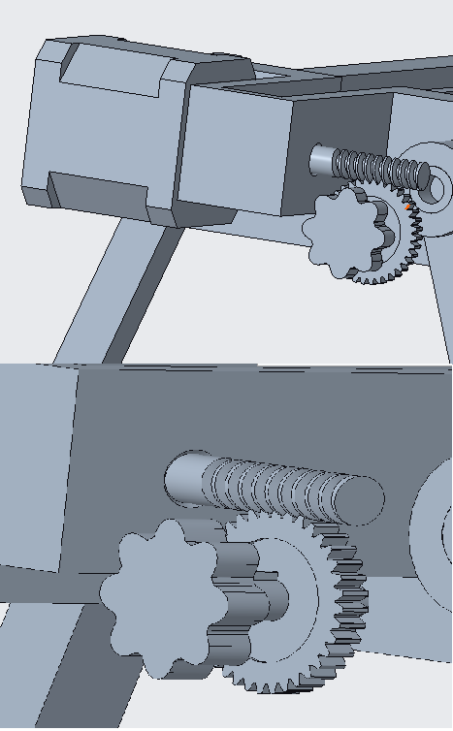

**6.Rocker Arm**

The rocker arm device consists of the connecting axis which links the rotary bearing seat and the fixed support (Figure 20). The cylinder at the bottom of the fixed support is mounted on a tripod, and on the adjustment of the crank arm is adjusted according to shooting requirements to achieve pan.

Figure Pan Device

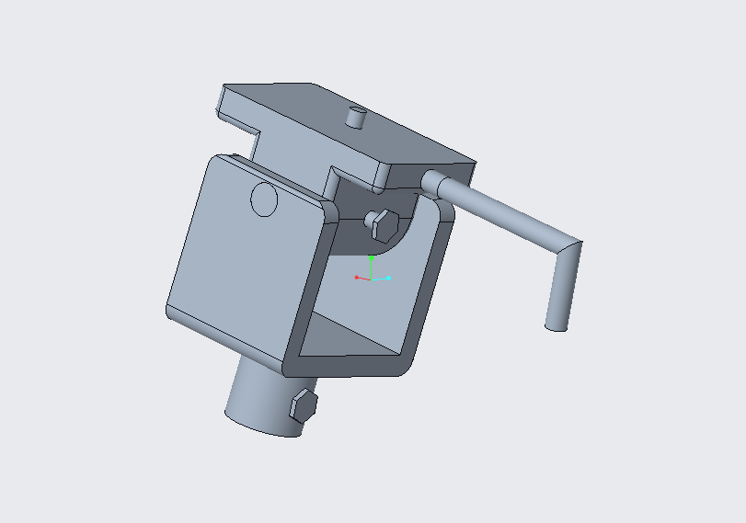

the top of the rotary bearing seat adopts, and the contact surface of the slider and the square nuts adopt high elastic rubber material with the effect of reducing vibration.

Pan System requires camera must be able to pan a minimum of 90º and a maximum of 140º.The camera slider is simplified into the schematic diagram to facilitate the establishment of the analysis model.

Figure Pan Device Schematic

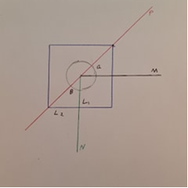

The installation datum of the connecting axis is the horizontal centre axis of the fixed support. Thus, the upward angle rotated the linear slider is same as the downward angle. According to the design requirement

The reliability of the rocker arm device determines the stability of filming. Through static analysis, the fixed support and the connecting axis need high design strength because of the concentrated stress exerted on the surface of the hole. Thus, the strength check of the fixed support is necessary

As the formulas are complicated, the deriving and solving processes demand many mathematical calculations during the checking and calculation of strength for shafts. Moreover, the solution of bending distortion of shafts with traditional integration is not only trivial and time-consuming but is error prone as well.

Figure Von mises stress

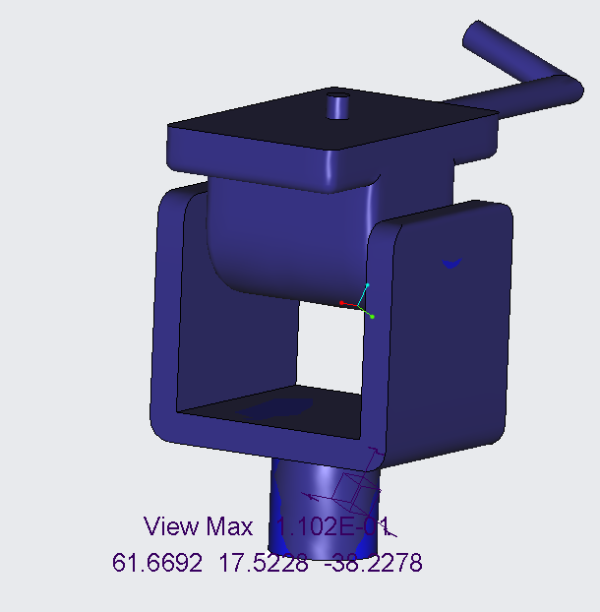

Using simulations, the stress that the pan device undergoes due to the weight of the camera in a fixed position is 1.1x10-1N/m2. This is due to using aluminum as the main structures build material and the pivot pin using a more rigid stainless steel for support purposes allowing the piece to support more weight should any additional lenes used that would add to the stress along the piece.

Figure Displacement

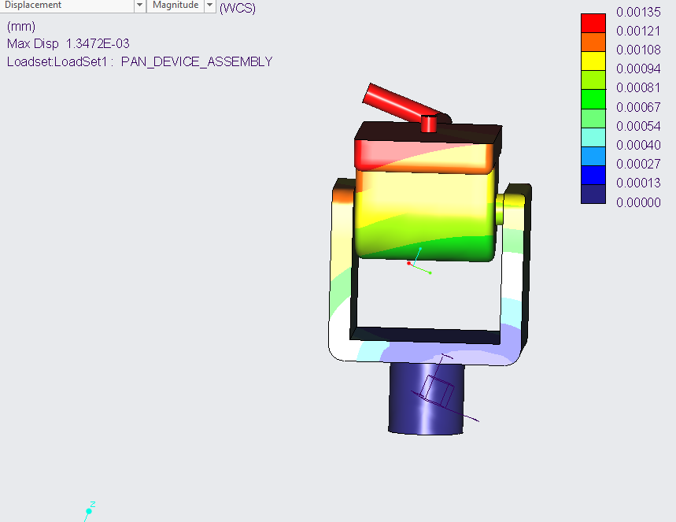

The final design aspects that needed to be examined were the level of displacement that the camera pan device would undergo, as a result it was important to keep the tolerance of .1mm in place as to ensure a quality product that can handle the weight. The simulation shows that the piece had far exceeded expectations that result in a maximum displacement of .00135mm

**Vibration**

The camera slider will usually work in different scenarios, which for some circumstances the resonant frequency from the environmental wind might cause more deflections of the slider and lead to the camera becoming unsteady, or even damage the slider. So, it is necessary to carry out the natural frequency study of the slider to design against resonance. In Creo simulate, a modal study was used, the load constraint was applied with gravity which would imitate the real conditions the camera is subject to, the simulate result is shown in Figure 24.

Figure Vibration Simulation

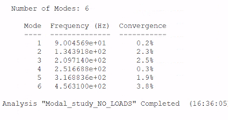

It has set 6 number of modes, and mode 1 has the minimum of the convergence where the frequency is 90Hz, hence, to avoid the resonance from the same frequency of the wind, the running frequency of the stepper motor should also avoid this frequency, which is 5400rpm of rotational speed.

**Control system**

Due to the easy implementation characteristic, Arduino UNO board was used in this project. It controls the stepper motor to achieve the two-direction motion and speed control of the camera also.

The electrical components are listed in Table 2.

Table 2 Electrical Components

|  |  |
| --- | --- |
| **Name** | **Amount** |
| 9V Battery | 1 |
| Stepper motor | 1 |
| Rotary potentiometer | 2 |
| LED | 2 |
| 1k ohms resistor | 2 |
| Capacitor | 1 |
| Arduino UNO | 1 |
| A4988 Driver | 1 |

Figure 25 shows the schematic of electronic components. A 9V battery is the power source for the stepper motor, and the A4988 driver was used for the driver to control the stepper motor through the transmission of the data to Arduino.

Two rotary potentiometers were used for interacting with the user, by rotating right and left potentiometers, the camera will go to the corresponding direction with the speed depend on how many degrees rotated.

Figure Schematic of Electronic Components

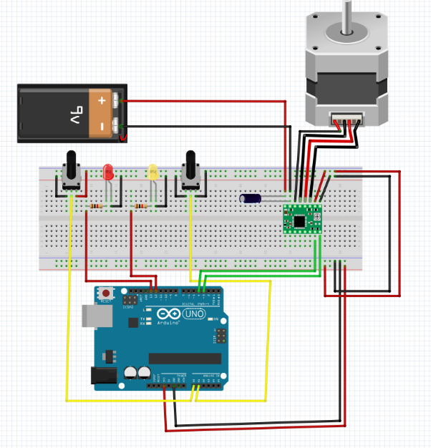

Two indicator LEDs will trigger depending on the direction of motion, the yellow light will switch on if the camera goes right and the red light will switch on if the camera goes left. The program for the whole control part is shown in the appendix.

**Conclusion and Recommendations**

On inspection of the motion and vibration studies, along with the final assembly it is deemed that the Ashby method for material selection process was a success as all specifications outlined in the problem statement were met. The structure of the slider in the design phase was optimised to become lighter by removing some of the material, the vibration analysis has conducted that the frequency should avoid 9Hz or it will cause resonance. By incorporating the Arduino board, the automatic linear motion was achieved. The addition of a knob next to the stepper motor allowed for manual utilization.

There are several features which the team would recommend for further work that would improve the design and overall functionality of the camera slider. A level bubble incorporated into the design to assist in levelling the slider. The possibility to include a brake to safely lock the camera pad in place when not in use. The ability to incorporate time-lapse systems. Integrate a counterbalance system to enable vertical camera movement.

**Appendix**

Figure Program for Control System

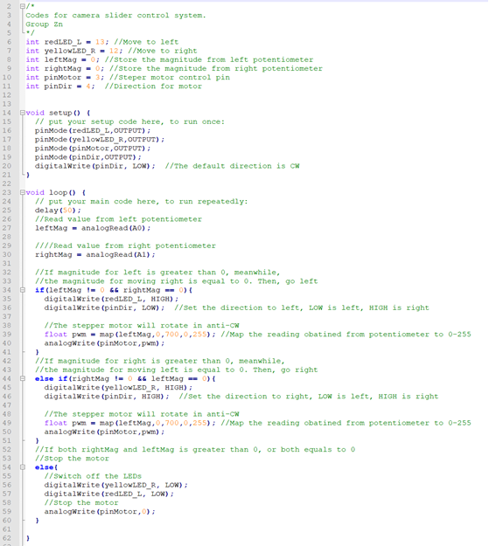

# **Bibliography**

Anon. (2010). *Factors of safety*. Retrieved from Engineering ToolBox: https://www.engineeringtoolbox.com/factors-safety-fos-d_1624.html

Mehmood, Z. (2018). *Material selection for Micro-Electro-Mechanical-Systems (MEMS) using Ashby's approach.* Materials Science.